JUnit Spring Test Exercises

Name: Shubham Sangram Bej

Aim
To implement and test Spring Boot applications using JUnit 5, Mockito, MockMvc, and Spring Boot Test for validating business logic, REST APIs, repository operations, exception handling, integration testing, and parameterised testing.

Objectives
- Learn unit testing using JUnit 5.
- Test service layer using Mockito.
- Test REST APIs using MockMvc.
- Perform integration testing with H2 Database.
- Implement repository testing.
- Handle exceptions using Spring Boot.
- Perform parameterized testing.
- Improve application reliability through automated testing.

Software Requirements
- Java JDK 21
- IntelliJ IDEA
- Apache Maven
- Spring Boot 3.5.16
- Spring Data JPA
- Spring Web
- H2 Database
- JUnit 5
- Mockito
- Git
- GitHub

Theory
Spring Boot provides comprehensive support for application testing through JUnit 5 and Spring Boot Test. Unit testing verifies individual methods, while Mockito isolates dependencies by creating mock implementations. MockMvc enables testing of REST controllers without deploying the application. Integration testing validates interactions between application components and the database. Parameterized testing allows the same test to execute with multiple input values, improving test coverage and reducing code duplication.

Advantages
- Faster bug detection
- Improved code reliability
- Automated testing
- Easy dependency mocking
- REST API validation
- Database testing using H2
- Better maintainability
- Increased code quality

Exercises Performed

Exercise 1 – Unit Testing CalculatorService

Description
A CalculatorService was created to perform addition. A JUnit 5 test verified that the add() method returned the expected result for given inputs.

Outcome
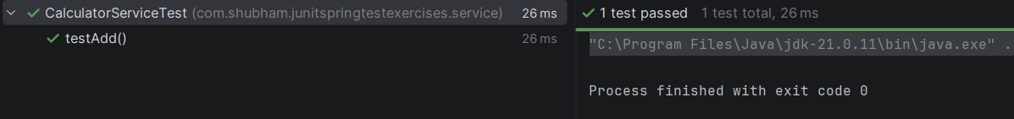

Exercise 2 – Mockito Repository Testing

Description
A UserRepository was mocked using Mockito. The UserService was tested independently by stubbing repository responses and validating the returned user object.

Outcome
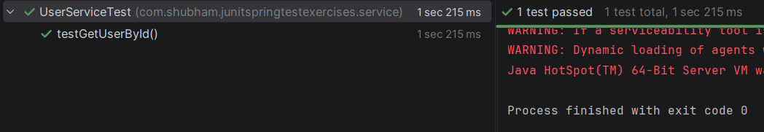

Exercise 3 – REST Controller Testing

Description
MockMvc was used to test the GET endpoint of UserController. The service layer was mocked, and the JSON response was validated without starting the web server.

Outcome
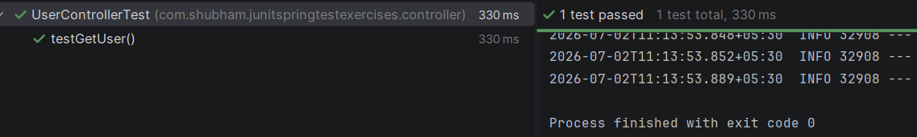

Exercise 4 – Integration Testing

Description
Integration testing was performed using the H2 in-memory database. User data was saved and retrieved through the repository to verify end-to-end database interaction.

Outcome

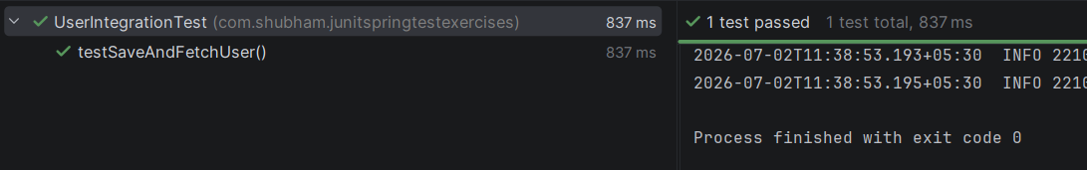

Exercise 5 – POST Endpoint Testing

Description
A POST endpoint was implemented and tested using MockMvc. A JSON request body was submitted, and the response was verified with HTTP status 201 Created.

Outcome

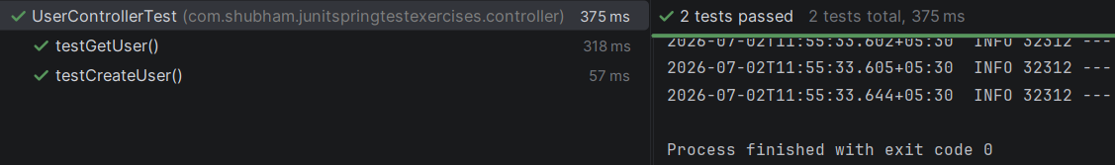

Exercise 6 – Exception Handling

Description
A custom UserNotFoundException was implemented. JUnit's assertThrows() method verified that the service correctly threw an exception when the requested user was not found.

Outcome

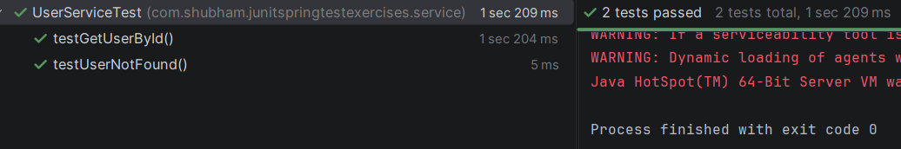

Exercise 7 – Custom Repository Query

Description
A custom repository method findByName() was implemented and tested to retrieve a user by name using Spring Data JPA.

Outcome

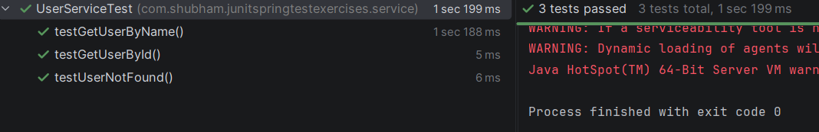

Exercise 8 – Global Exception Handling

Description
A global exception handler using @RestControllerAdvice was created to handle application exceptions and return appropriate HTTP status codes and messages.

Outcome

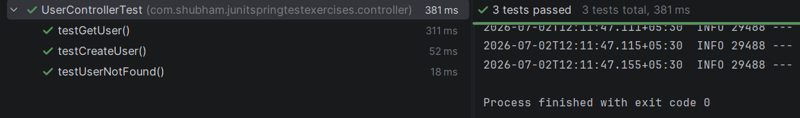

Exercise 9 – Parameterised Testing

Description
A parameterised JUnit 5 test was created using @ParameterizedTest and @CsvSource to validate multiple input combinations for the calculator service.

Outcome

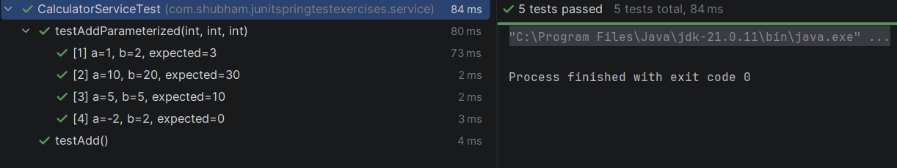

Project Structure
JUnitSpringTestExercises
│
├── src
│ ├── main
│ │ ├── controller
│ │ ├── entity
│ │ ├── exception
│ │ ├── repository
│ │ ├── service
│ │ └── resources
│ │
│ └── test
│ ├── controller
│ ├── service
│ └── UserIntegrationTest
│
├── screenshots
├── README.md
└── pom.xml

Results
Successfully implemented:
- Unit testing using JUnit 5
- Mockito-based service testing
- REST API testing using MockMvc
- Integration testing using H2 Database
- Repository testing
- Exception handling
- Global exception handling
- Parameterized testing
- Spring Boot testing framework
All test cases executed successfully.

Conclusion
The JUnit Spring Test Exercises provided practical experience in testing Spring Boot applications using JUnit 5, Mockito, MockMvc, and Spring Boot Test. Unit tests, integration tests, repository tests, REST API tests, and exception handling were successfully implemented. These exercises improved understanding of automated testing practices and demonstrated how proper testing increases application reliability, maintainability, and overall software quality.

References
- Spring Boot Documentation – https://spring.io/projects/spring-boot
- JUnit 5 User Guide – https://junit.org/junit5/docs/current/user-guide/
- Mockito Documentation – https://site.mockito.org/
- Spring Framework Documentation – https://docs.spring.io/spring-framework/reference/
- Apache Maven Documentation – https://maven.apache.org/

